PE Definition

Description: A highly efficient, instruction-set driven Processing Element (PE) for accelerating quantized neural network inference.

PE Operation

The PE operates as an instruction-driven hardware accelerator designed to offload computationally intensive neural network inference tasks. Controlled by a Chip Select signal, the PE transitions between a no-operation state and an active execution mode. The PE operates on quantized signed integers, which serve as efficient approximations of the original floating-point number model parameters. When enabled, the PE samples the operational code and the input operands according to their validity signals, causing activity in the following clock cycle.

Following the input validity signals, two registers ingest signed 32-bit packed integer operands, typically representing neural network inputs and weights. The PE can dynamically reconfigure its arithmetic core to support high-fidelity INT8 operations or high-throughput INT4 operations. It also supports a multi-cycle uint-by-int scalar multiplication for rescaling.

The computational datapath executes operations sequentially. It first performs a series of Multiply and Accumulate (MAC) operations to collect partial sums, adds a bias value, then applies the uint-by-int multiplication to finalize the arithmetic phase into the 64-bit register. Once all math operations are complete, the massive 64-bit signed accumulator is shifted and saturated down to a 4/8-bit signed integer. A hardware-based activation function, selected by the same configuration register, then processes this scaled value to finalize the inference result. This final activation output is driven to the output bus.

The power-up state of the PE is undefined. For a known initial state, the user must assert the active-low asynchronous reset, which clears all internal registers and initializes the datapath to a default idle state with a zeroed accumulator. Upon release of reset, pe_ready rises immediately, indicating the PE is ready to accept its first instruction.

Instruction Set Architecture (ISA)

Opcode Table

Opcode | Mnemonic | Full Name | Description
00000 | NOP | No Operation | System idle; all internal registers hold their current state.
00001 | RST_ACC | Reset Accumulator | Clears the 64-bit signed accumulator register to zero.
00010 | MAC | Multiply and Accumulate | PE treats operand_A and operand_B as packed signed integers in the precision mode selected by the configuration register.
00011 | ADD_BIAS | Add Bias | Adds the 32-bit bias to the accumulator from the operand_B bus.
00100 | SCALE | UInt-By-Int Multiplication | Multi-cycle scaling; multiplies the lower 32 bits of the accumulator by operand_B and overwrites the accumulator for scaling. Also loads the 6-bit shift-amount register from operand_A[5:0] at cycle 0.
00101 | LOAD_CFG | Load Configuration | Loads the 4-bit PE configuration register from operand_A_reg[3:0].
00110 | EXEC_PP | Execute Post-Processing | PE requantizes the 64-bit accumulator using the pre-loaded shift amount and applies the selected activation function.
00111 | READ_ACC_BYTE | Read Accumulator Byte | Routes one byte of the 64-bit accumulator, selected by operand_A[2:0], to data_out.
01000 | READ_CFG | Read Configuration Register | Routes the configuration register value to data_out.
01001 - 11111 | RSV | Reserved | Reserved for future instruction expansion.
Table 1. Operational-Code.

Instructions Breakdown

- NOP: No operation.
- RST_ACC: This instruction clears the accumulator. No operands are required on the data buses for the execution of this instruction.
- MAC: Performs a multiply-accumulate operation on operand_A and operand_B, based on the current precision mode. The element-wise products are summed and added to the accumulator.
If INT8 mode:
$$acc_{n+1}=acc_{n}+\sum_{i=0}^{3}{(signed\left(op_A[8i+7:8i]\right)×signed\left(op_B[8i+7:8i]\right) }$$
If INT4 mode:
$$acc_{n+1}=acc_{n}+\sum_{i=0}^{7}{(signed\left(op_A[4i+3:4i]\right)×signed\left(op_B[4i+3:4i]\right) }$$
- ADD_BIAS: The 32-bit signed integer on operand_B is added directly to the current 32-bit accumulator sum.
- SCALE: Initiates a multi-cycle unsigned-by-signed multiplication. The PE multiplies the lower 32 bits of the current 64-bit accumulator by the unsigned 32-bit scaling factor presented on operand_B. The 64-bit product overwrites the accumulator value. The 6-bit shift amount for subsequent requantization is received on operand_A[5:0] and captured on the first cycle of the operation. While the multi-cycle operation executes, the PE negates pe_ready and does not accept new instructions. Upon completion, the PE pe_ready signal goes high.
- LOAD_CFG: This instruction loads the 4-bit PE configuration register from operand_A[3:0]. See the Configuration Register section for the full encoding table.
- EXEC_PP: The PE reads the 64-bit accumulator, applies an arithmetic right-shift using the pre-loaded 6-bit shift amount, rounds this intermediate result to the nearest integer, clamps the result to the signed 4/8-bit range, and passes it through the selected activation function. The final result is routed to the output register.
- READ_ACC_BYTE: The PE receives an index on operand_A[2:0] and outputs the corresponding accumulator byte on data_out.
- READ_CFG: The PE outputs the configuration register to data_out, zero-padded to 8 bits.

I/O Interface

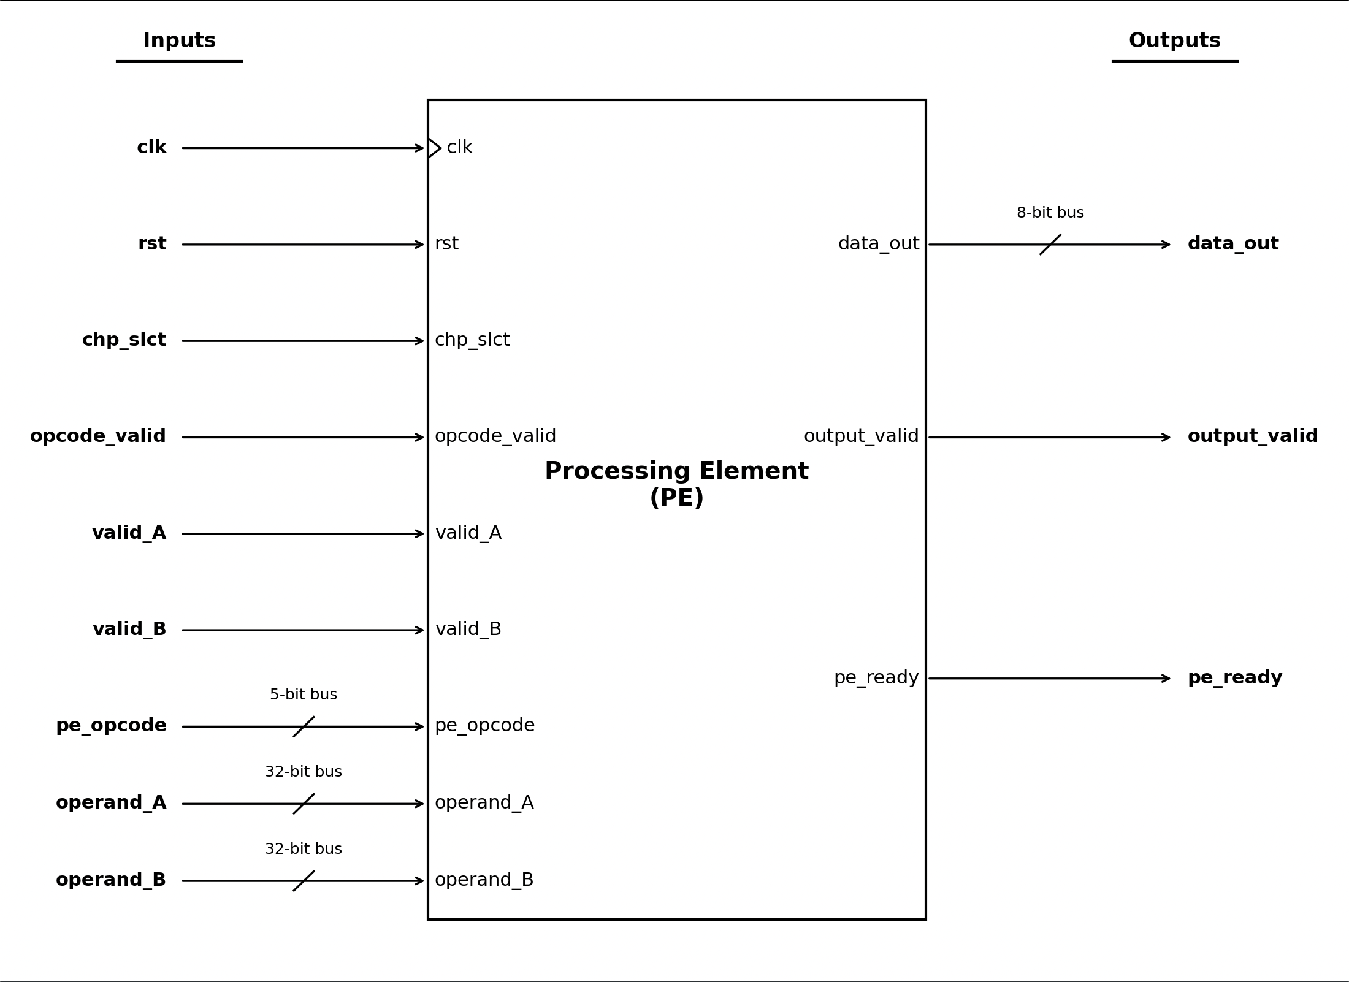
Figure 1. PE interface.

The following table defines the input and output ports of the Processing Element. All signals are sampled on the rising edge of the main system clock.

Signal Name | Signal Type | Width | Direction | Function | User Note
clk | Global | 1 bit | Input | System Clock | Main system clock.
rst | Global | 1 bit | Input | System Reset | Active-low asynchronous reset. Clears all internal registers to a defined state.
chp_slct | Control | 1 bit | Input | Chip Select | When inactive, new instructions and operands are not sampled. Instructions already captured into the internal opcode register continue to completion.
valid_A | Control | 1 bit | Input | Operand A Validity | When high, the operand_A register captures the data on the operand_A bus. Independent of the opcode and operand_B validity signals.
valid_B | Control | 1 bit | Input | Operand B Validity | When high, the operand_B register captures the data on the operand_B bus. Independent of the opcode and operand_A validity signals.
valid_opcode | Control | 1 bit | Input | Operational Code Validity | When high, the opcode register captures the instruction on the pe_opcode bus. Independent of the operand validity signals.
operand_A | Data | 32-bit bus | Input | NN Inputs / Weights / Configuration | Packed integer data bus. Interpretation depends on the current instruction; see the ISA section.
operand_B | Data | 32-bit bus | Input | NN Inputs / Weights / Bias / Scaling Factor | Packed integer data bus. Interpretation depends on the current instruction; see the ISA section.
pe_opcode | Control | 5-bit bus | Input | Operational Code | The instruction that needs to be executed. See ISA section for encodings.
data_out | Data | 8-bit bus | Output | NN Output | The final 8-bit quantized inference result following EXEC_PP, a single accumulator byte during READ_ACC_BYTE, or the zero-padded configuration register value during READ_CFG.  Note: Following EXEC_PP in INT4 mode, data_out[3:0] holds the result and data_out[7:4] is don't-care.
output_valid | Control | 1 bit | Output | Output Validity | Pulsed high for one clock cycle following an EXEC_PP, READ_ACC_BYTE, or READ_CFG instruction, indicating that the data on data_out is a valid result.
pe_ready | Control | 1 bit | Output | Ready Flag | Flow-control flag. When high, the PE is ready to accept new instructions. Driven low during multi-cycle operation (SCALE).
Table 2. I/O.

Instruction Sampling

The two operand registers (operand_A, operand_B) update on the rising clock edge when their respective validity signal (valid_A or valid_B) is high, qualified by pe_ready and chp_slct.

The opcode register updates on the rising clock edge when valid_opcode is high, qualified by pe_ready and chp_slct.

If chp_slct deasserts after an instruction has been captured, the PE does not accept new instructions, but the already-captured instruction completes normally. Any multi-cycle instruction, once accepted, runs to completion with stable operands even if the PE is deselected mid-operation.

Configuration Register

The PE contains a 4-bit configuration register with the following encoding:
Bit(s) | Field | Value | Mnemonic | Effect
[3] | Mode | 0 | INT4 | Precision mode: eight 4×4 MAC operations per cycle.
[3] | Mode | 1 | INT8 | Precision mode: four 8×8 MAC operations per cycle.
[2:0] | Activation | 000 | IDENTITY | Activation function: Identity (pass-through).
[2:0] | Activation | 001 | RELU | Activation function: ReLU.
[2:0] | Activation | 010 | LRELU1 | Activation function: Leaky ReLU (slope α₁).
[2:0] | Activation | 011 | LRELU2 | Activation function: Leaky ReLU (slope α₂)
[2:0] | Activation | 100 | TANH | Activation function: Tanh.
[2:0] | Activation | 101 | SIGMOID | Activation function: Sigmoid.
[2:0] | Activation | 110 | GELU | Activation function: GELU.
[2:0] | Activation | 111 | SILU | Activation function: SiLU.
Table 3. Configuration register encoding.

A single LOAD_CFG instruction configures both the precision mode and the activation function at once.

The reset default is 4'b0000: INT4 precision mode and Identity activation function.

The Leaky ReLU slopes are α₁ = 0.015625 and α₂ = 0.25. For activation function details, refer to the Activation Functions section.

Activation Functions

This section details the activation functions supported by the PE.

Piecewise Linear Activation Functions

In the following equations, x designates the rescaled MAC result, generated by applying the multiplication and shift factors received with the SCALE instruction.

- Identity: $data_out=x$
- ReLU: $data_out=\max\left(0, x\right)$
- Leaky ReLU 1: $data_out=x$ for $x≥0$, and $\left\lfloor 0.015625∙x\right\rfloor$ for $x<0$
- Leaky ReLU 2: $data_out=x$ for $x≥0$, and $\left\lfloor 0.25∙x\right\rfloor$ for $x<0$

Smooth Non-Linear Activation Functions

To maximize meaningful input range and output resolution, we scale the inputs to the activation functions, and we scale and bias the outputs. The input scaling factors S_{x}, output scaling factor S_{y}, and bias factor B, for the different activation functions are detailed in the tables below.

All output values are rounded to the nearest integer representation.

In the following equations, x designates the rescaled MAC result, generated by applying the multiplication and shift factors received with the SCALE instruction, and divided by the input scaling factors S_{x}: $x=\frac{scaled_MAC_result}{S_{x}}$.
- Sigmoid: $y=\frac{1}{{1+e}^{-x}}$
- Tanh: $y=\frac{e^{x}-e^{-x}}{e^{x}+e^{-x}}$
- SiLU: $y=x⋅σ(x)$

- GELU: $y=\frac{1}{2}x⋅\left[1+\operatorname{erf}\left(\frac{x}{\sqrt{2}}\right)\right]$
Quantization and Scaling

The inputs were scaled using the following formula: $Input Bit Value=x∙S_{x}$.

Precision Mode | Activation Function | $$S_{x}$$ | x Range | x Resolution
INT8 | Sigmoid | $$21.16666$$ | $$[-6.047244, 6]$$ | $$0.047244$$
INT8 | Tanh | $$31.75$$ | $$[-4.0315, 4]$$ | $$0.0315$$
INT8 | GELU / SiLU | $$15.875$$ | $$[-8.063, 8]$$ | $$0.063$$
INT4 | Sigmoid | $$1.16666$$ | $$[-6.85714, 6]$$ | $$0.85714$$
INT4 | Tanh | $$1.75$$ | $$[-4.57143, 4]$$ | $$0.57143$$
INT4 | GELU / SiLU | $$0.875$$ | $$[-9.14286, 8]$$ | $$1.14286$$
Table 4. Input scaling and sampling regions.

The PE’s output, data_out, is generated from y using the following formula: $data_out=\frac{y-\hat{B}}{S_{y}}$.

Precision Mode | Activation Function | Bias ($\hat{B}$) | $$S_{y}$$
INT8 | Sigmoid | $$0$$ | $$7.874∙{10}^{-3}$$
INT8 | Tanh | $$3.9216∙{10}^{-3}$$ | $$7.874∙{10}^{-3}$$
INT8 | SiLU | $$3.877$$ | $$0.0324645$$
INT8 | GELU | $$3.931$$ | $$0.032$$
INT4 | Sigmoid | $$0$$ | $$0.14286$$
INT4 | Tanh | $$0.06666$$ | $$0.13333$$
INT4 | SiLU | $$4.13672$$ | $$0.5519$$
INT4 | GELU | $$4.1873$$ | $$0.54466$$
Table 5. Output scaling parameters.

For example, when using INT8 precision and GELU activation, if scaled_MAC_result is 100:
scaled_MAC_result = 100 (x = 6.299) $→$ data_out = 74 (y = 6.299)

When using INT4 precision and SiLU activation, if scaled_MAC_result is -1:
scaled_MAC_result = -1 (x = -1.142) $→$ data_out = -8 (y = -0.27848 $≈$ 0)

